Infosys Springboard Virtual Internship 6.0 Completion Report
Batch Number: 4- BudgetWise AI based Expense Forecasting Tool
Start date : 13-10-2025
Names: Group-C
1 | Kavya Sampathirao
2 | Kokila M
3 | Nandi Mangalam Geervani
4 | Poolasetty Chandana
5 | Pratyasha Basak
6 | Priyanshi Jayant

Internship Duration: 40 Days

1. Project Title
SpendGenie-BudgetWise AI based Expense Forecasting Tool
2. Project Objective

SpendGenie is an AI-driven personal finance management system designed to help users understand, track, and predict their spending activities. Using machine learning models, it analyzes historical financial data, identifies spending behaviors, and provides accurate forecasts for future expenses.

The tool features:
✔ Automated CSV ingestion and data cleaning
✔ Smart categorization of user expenses
✔ Interactive dashboards using Plotly for visual insights
✔ AI-powered predictions using linear regression
✔ Personalized budgeting recommendations
✔ Light/Dark theme toggle, responsive sidebar, and chatbot support.

With adaptive learning, SpendGenie continuously improves its predictions as more user data is added. The system is designed for individuals, families, and small businesses to make smarter financial decisions, plan budgets effectively, and cultivate better savings habits.

3. Project description in detail
BudgetWise is an innovative SpendGenie was developed to address the growing need for intelligent digital financial assistants capable of analyzing spending behavior and forecasting future expense trends. During the internship, we built an end-to-end web application using Flask, SQLAlchemy, Pandas, Plotly, and Machine Learning models to create a real-time, AI-powered expense management dashboard.
The system supports CSV upload of user financial records and automatically cleans and standardizes the data by detecting formats, identifying date and amount columns, removing inconsistencies, and classifying expenses into categories. Through ML algorithms like Linear Regression, SpendGenie predicts next-month expenses both overall and category-wise.
SpendGenie provides users with:
- Interactive visualizations including pie charts, bar graphs, and line charts
- Monthly and yearly financial summaries
- Peak spending day analysis
- AI chatbot assistance
- Secure login, registration, and session handling
- Theme toggle (light/dark mode) and responsive UI with a sidebar and hamburger menu
The backend is robust, handling edge cases such as malformed CSV files, mixed column names, missing values, and negative or bracketed amounts. The self-learning AI system adapts based on new expenses added by the user manually or via CSV uploads.
SpendGenie aims to bridge the gap between AI and personal finance by offering intuitive tools, accurate predictions, and meaningful insights, empowering users to gain control over their financial habits.

4. Timeline Overview
Week | Activities Planned | Activities Completed
Week 1 | Requirement gathering, project scope definition, tech stack discussion, Research on forecasting models and dataset exploration. | Requirements finalized, project scope documented, team roles assigned, Model selection completed (Linear Regression), dataset samples prepared.
Week 2 | Backend setup with Flask, user authentication module,  CSV upload system and data preprocessing pipeline | Login/Signup implemented using Flask, SQLAlchemy, bcrypt; Automatic column detection & cleaning implemented.
Week 3 | Expense forecasting model training and testing; Dashboard design and visualization. | Monthly and category-wise forecasting integrated; Interactive charts (monthly trend, categories, yearly graph) completed.
Week 4 | System integration: AI model + dashboard + user input; Testing, debugging, deployment, and documentation. | Added add-expense page, forecasting, and dataset updates; Bugs fixed, UI finalized, chatbot integrated, project deployed

5a. Key Milestones
Milestone | Description | Date Achieved
Project Kickoff | Project kickoff defined objectives, scope, and roles. | 13 – Nov - 2025
Prototype/First Draft | Developed the prototype for resume matching and skill recommendation. | - - 2025
Mid-Term Review | Completed mid-term review to assess progress and refine project approach. | - - 2025
Final Submission | Submitted the completed Budgetwise project with full functionality and documentation. | - - 2025
Presentation | Prepared and delivered the project presentation showcasing features and outcomes. | - - 2025

5b. Project execution details

- Requirement Analysis: Defined core features such as tracking, forecasting, visualization, and chatbot.
- Technology Selection: Flask for backend, SQLAlchemy for DB, Plotly for charts, ML models.
- System Design: Database schema, model structure, dashboard layout, sidebar navigation.
- Data Collection: Used sample financial datasets and user-uploaded CSV data.
- Data Preprocessing: Automatic detection of date/amount columns, cleaning, normalization.
- Model Development: Linear Regression for forecasting future expenses.
- Frontend Development: Dashboard, charts, theme toggle, responsive sidebar.
- Backend Development: Expense APIs, prediction routes, chatbot integration.
- Testing: Validated accuracy, tested with multiple datasets and user inputs.
- Deployment: Completed deployment with documentation and user manual.

6. Snapshots / Screenshots
Step 1 : Go to Github and clone the Repository in your system then open in colab to do the execution , here is the github repo link :
SpendGenie-github
Step 2 : Start running the code
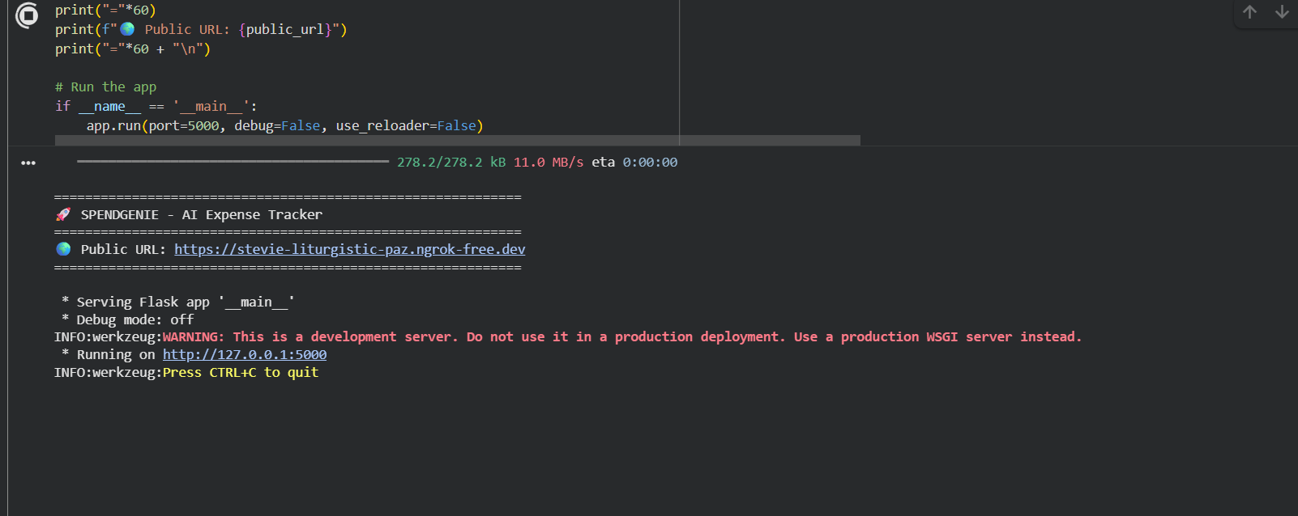
Step 3: Here is the Landing page with basic navigation and a chatbot for helping user
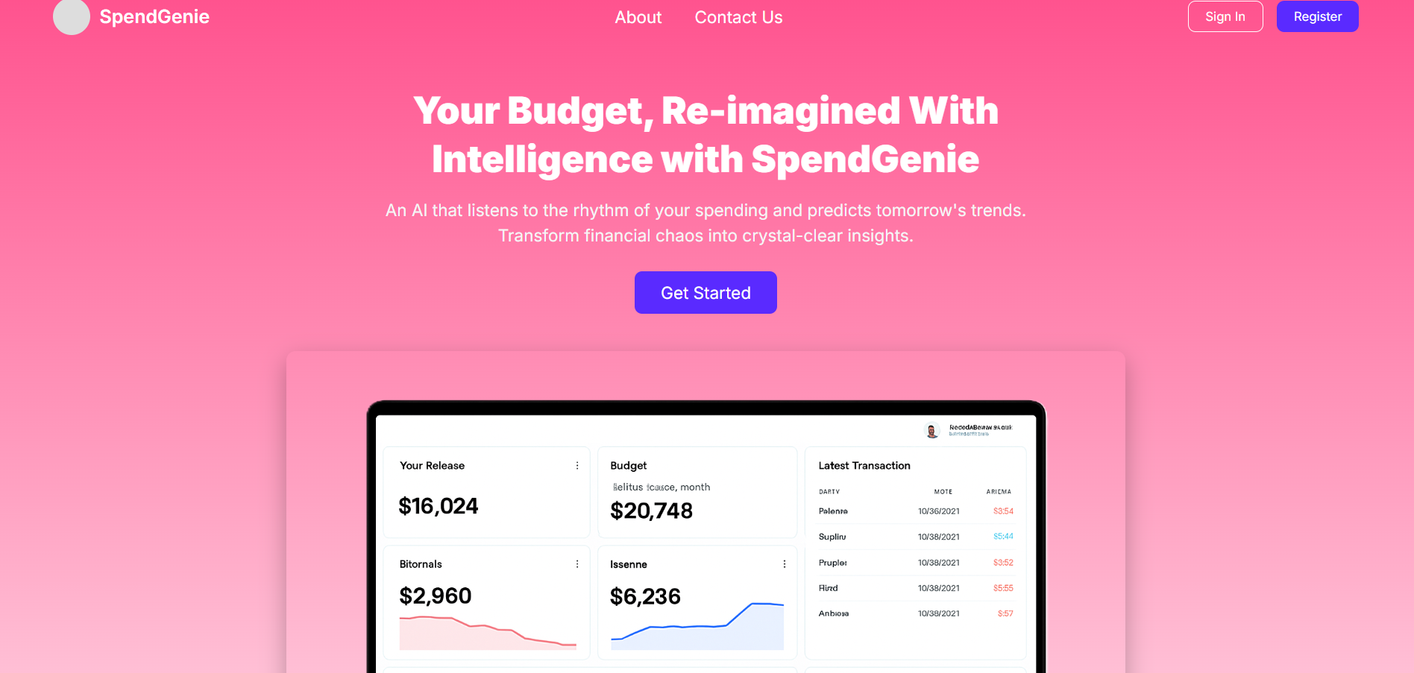

Step 4: After clicking on Login/Signup here user need to register and log in for Authentication.
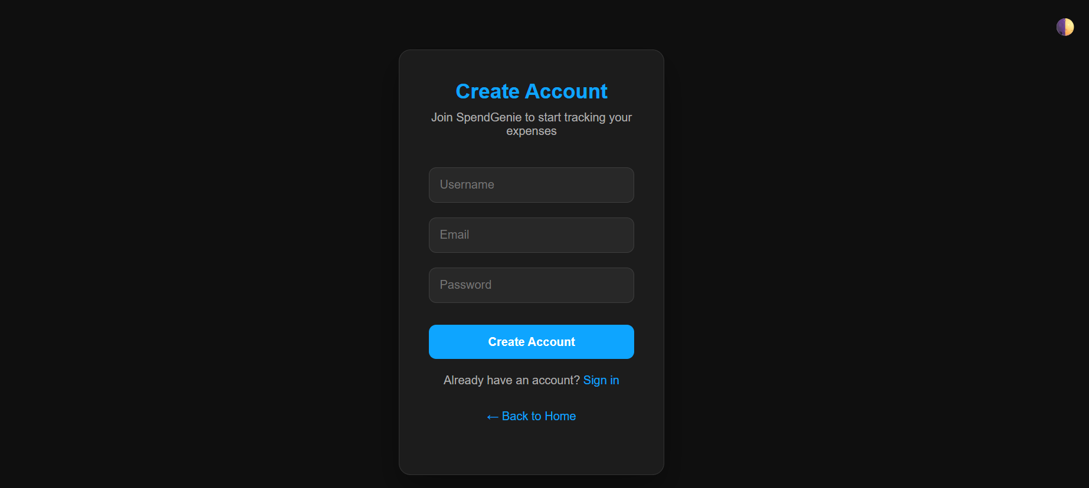
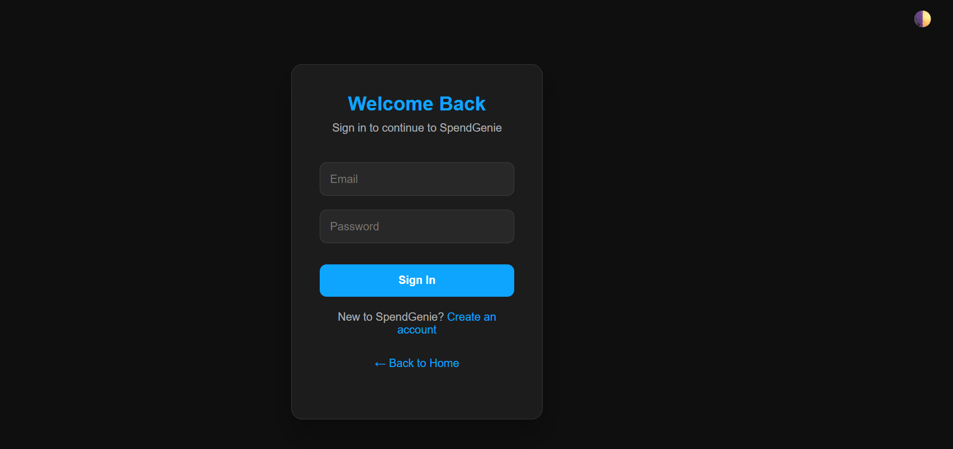

Step 5: Upload page: User uploads CSV of expenses.
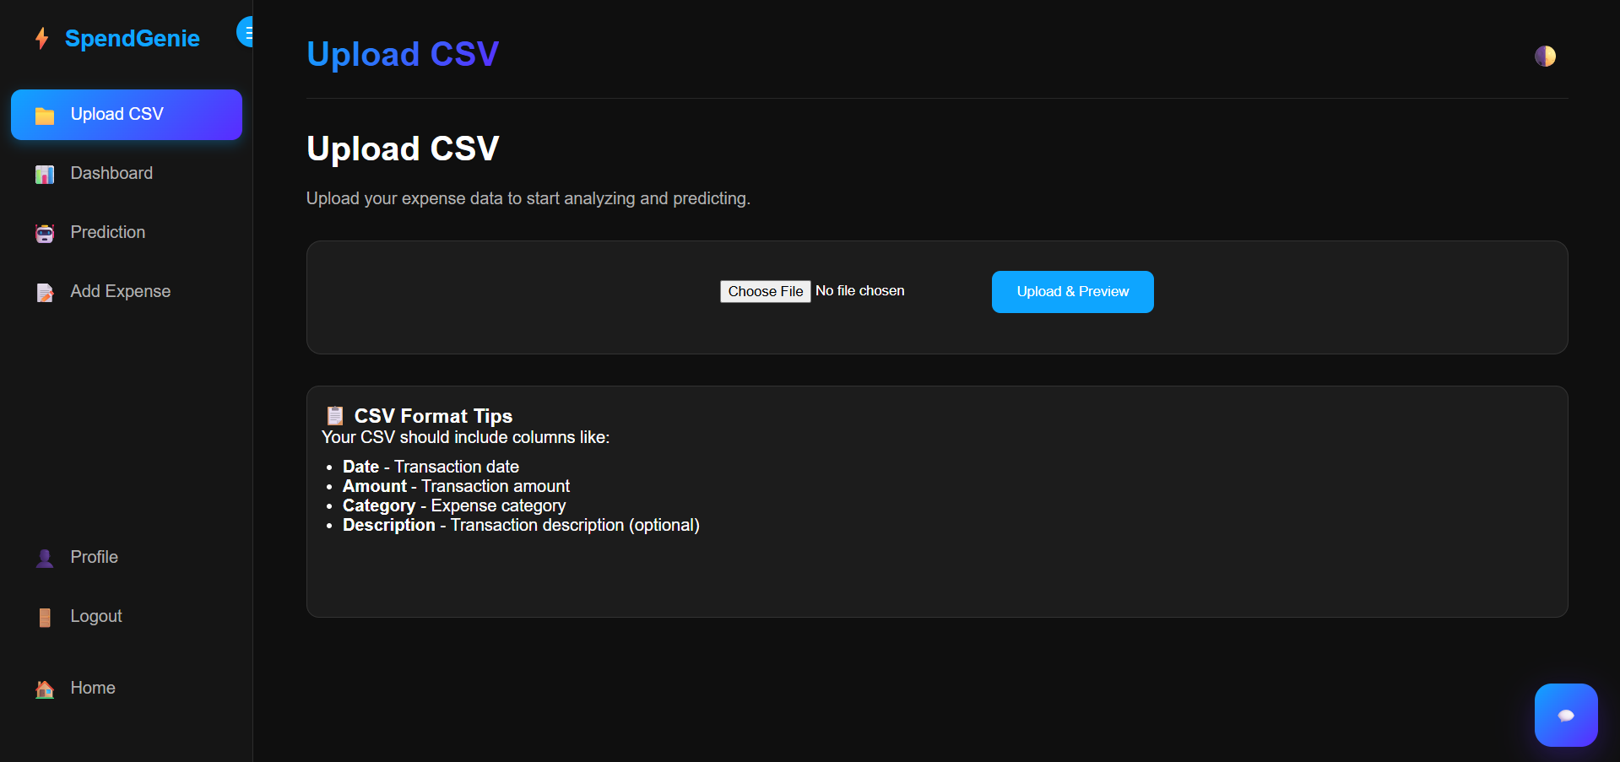
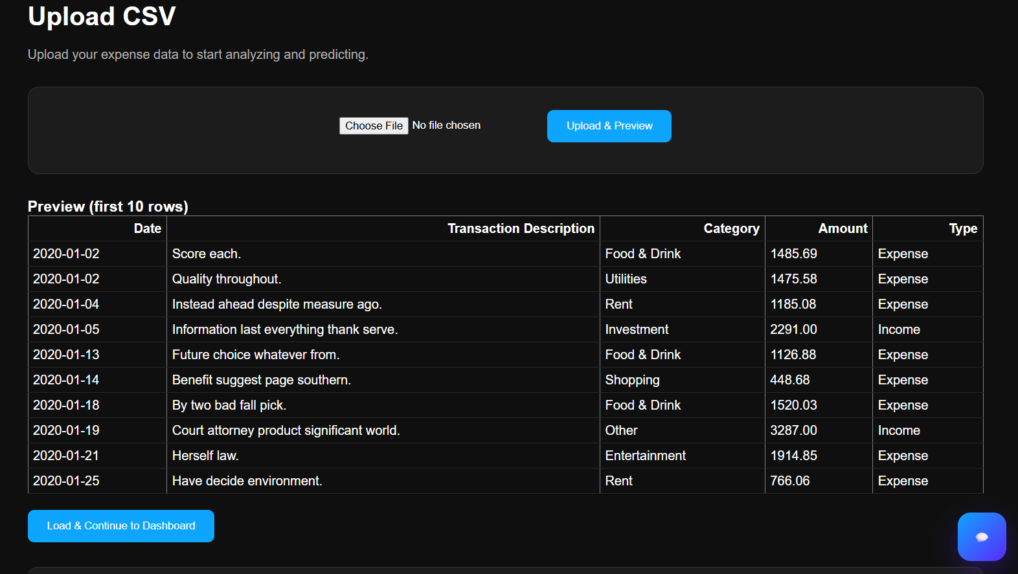

Step 6: After submitting user input it showcase the basic data on as a dashboard.
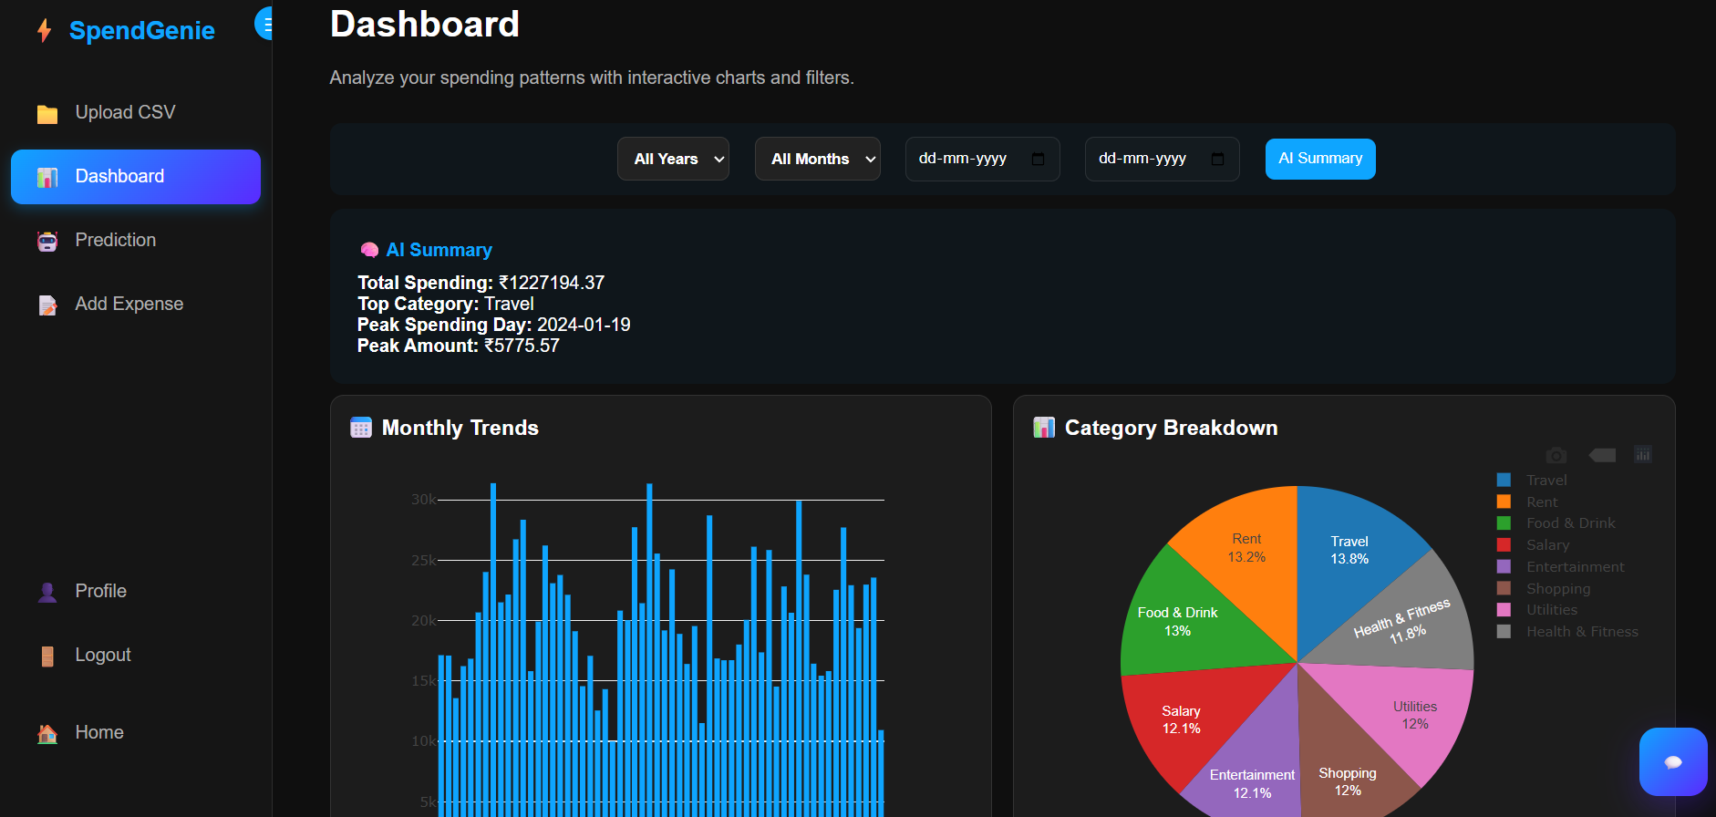
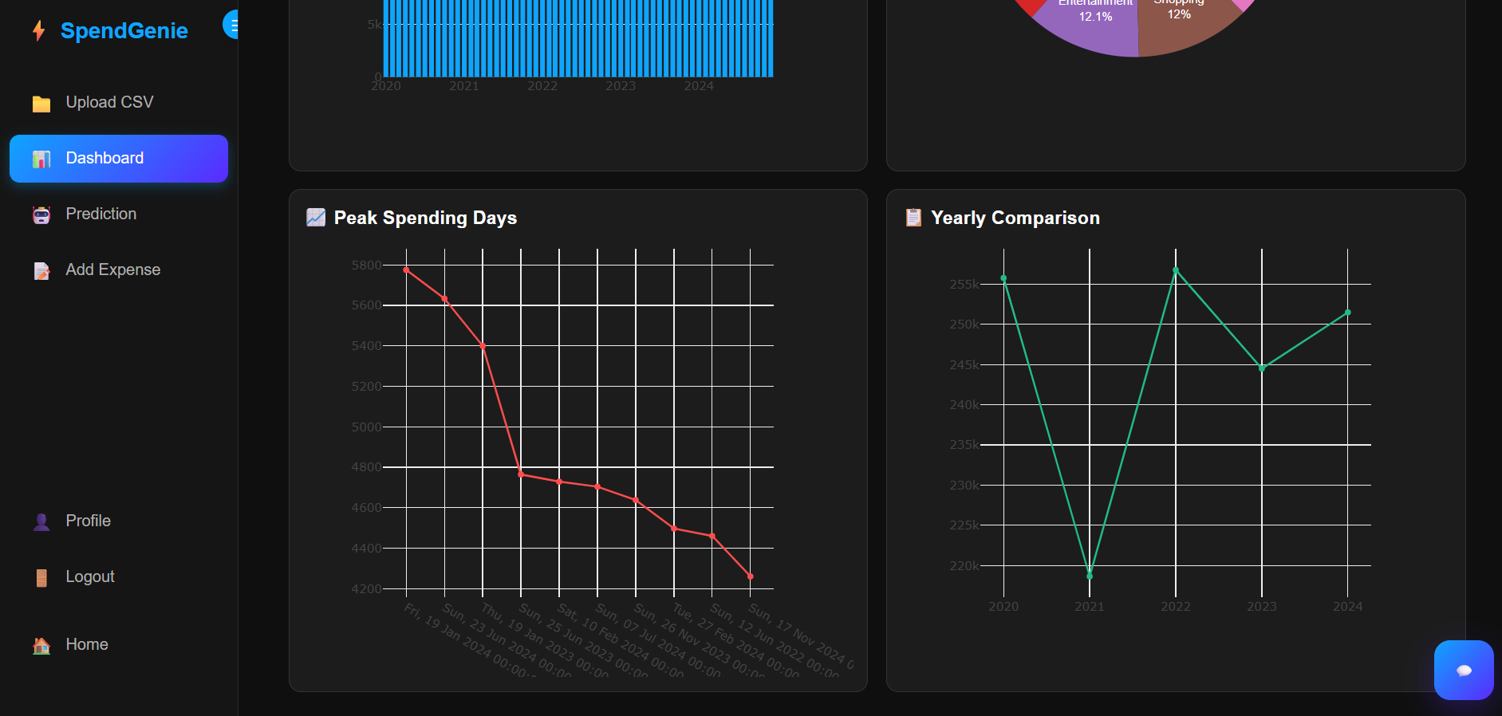

Step 7: In these Expense tab user can add new expense like food, transport and others.
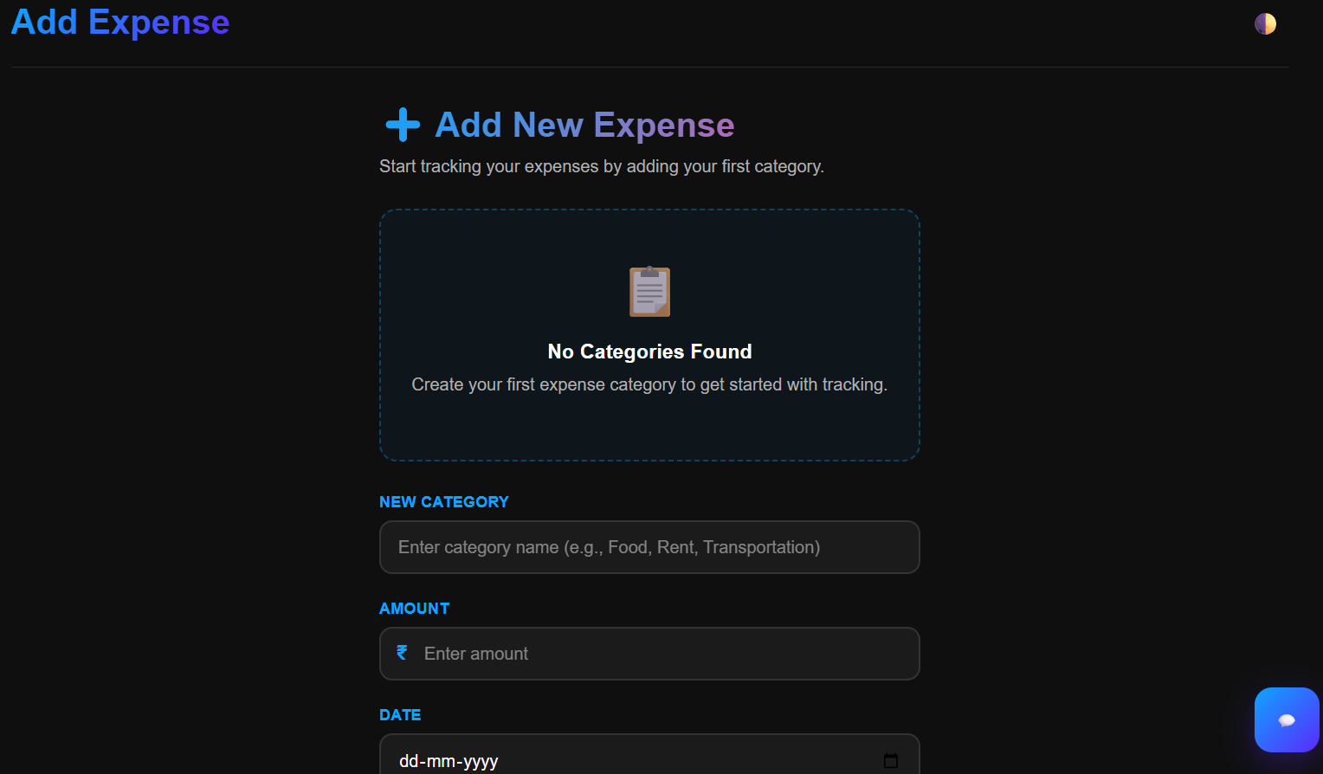
Step 8: Prediction page-forecast the expense (Visualize and shows the future expense).
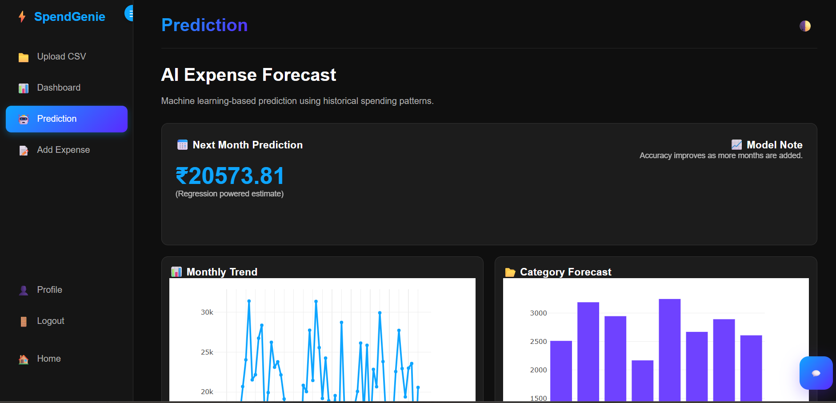

Step 9: Here is basic report also with graph and charts.we can download the charts report
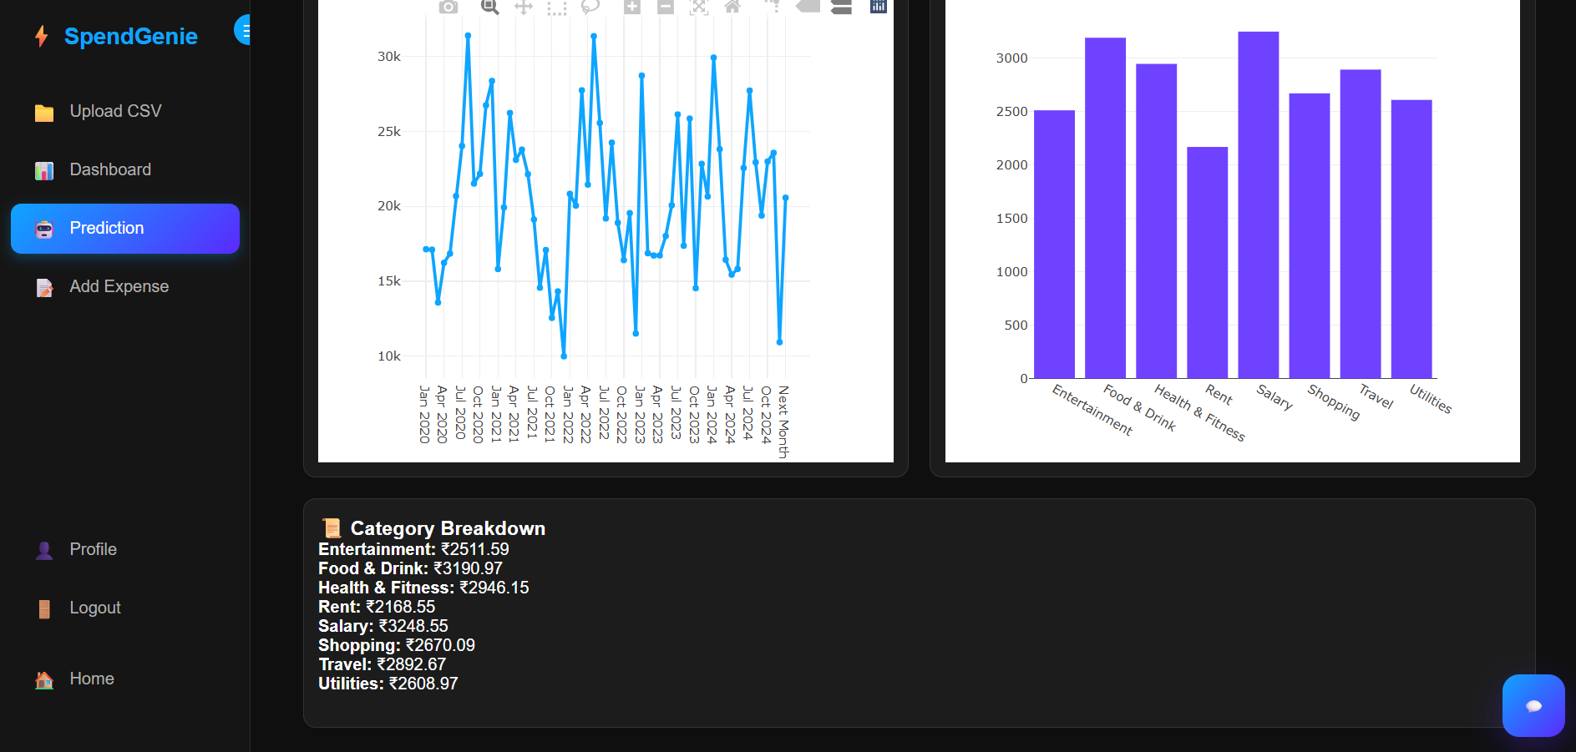
Step 10: Using Chatbot user can communicate with Chatbot
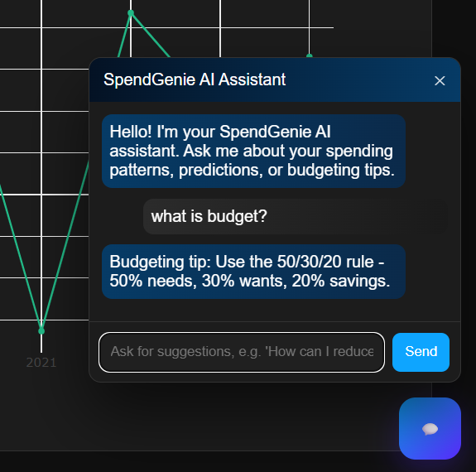

End : Finally here is the Profile section.
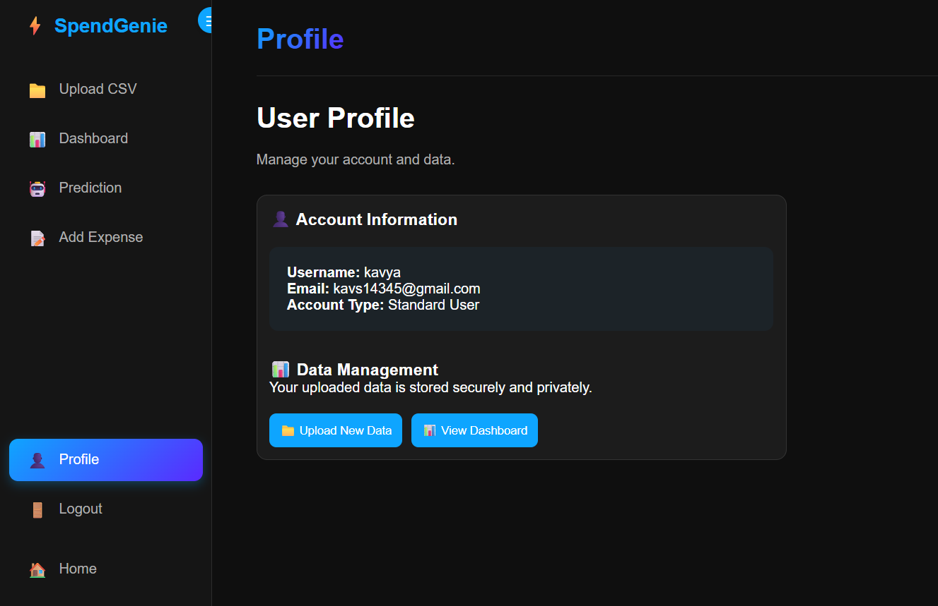

7. Challenges Faced
- CSV Data Quality Issues – Mixed formats, missing columns, negative values.
- Column Detection – Handling different naming conventions (e.g., “amt”, “txn_value”).
- Prediction Accuracy – Financial patterns vary widely, requiring model tuning
- UI Responsiveness – Ensuring sidebar + theme toggle works on all screens
- Session Management – Users required isolated upload directories
- Real-Time Updates – Dashboard must react to new expenses immediately
- Integration Complexity – Combining ML model, Flask APIs, JS dashboard
- Security – Password hashing, session isolation, input sanitization
- Time Management – Balancing front-end, backend, ML, and testing phases
- Testing Across Datasets – Multiple CSV formats needed to be validated.

8. Learnings & Skills Acquired

- Hands-on experience with Flask, SQLAlchemy, Pandas, Plotly
- Improved ability to process and clean complex financial datasets
- Developed knowledge of time-series forecasting and regression
- Learned full-stack development (UI, backend, APIs)
- Strong understanding of data visualization and dashboarding
- Improved debugging, testing, and deployment skills
- Enhanced teamwork and agile collaboration abilities
- Learned financial domain concepts: budgeting, categorization, spending patterns
- Experience integrating AI chatbot support within web apps

9. Testimonials from team

Team Member 1:
"SpendGenie helped me understand how ML can be integrated with real-world financial data and refined my preprocessing skills."

Team Member 2:
" I learned how to build secure authentication and interactive dashboards, enhancing both my backend and frontend skills."

Team Member 3:
" The project improved my problem-solving skills and taught me how to create intuitive user experiences with data-driven insights."

Team Member 4:
" This internship boosted my confidence in Flask development and ML model integration for practical solutions."

10. Conclusion

The SpendGenie project successfully delivered an AI-based expense tracking and forecasting system with intuitive dashboards, machine learning models, and a user-friendly interface. It demonstrates how predictive analytics can support personal and business financial planning. Through the 40-day internship, our team significantly strengthened technical, analytical, and collaborative skills, while building a real-world, intelligent application from scratch.

11. Acknowledgements
Thank the organization, mentor, and any team members who supported your internship journey.
We would like to express my sincere gratitude to Infosys for providing me the opportunity to work on the BudgetWise AI based Expense Forecasting Tool project and gain hands-on experience in AI and ML applications.
We especially thankful to my mentor, Sangeetha, for their constant guidance, support, and valuable insights throughout the internship. Their mentorship helped me overcome challenges and grow both technically and professionally.
We also appreciate the collaboration, hard work, and dedication of all our team members who contributed to the successful completion of SpendGenie, for their collaboration, encouragement, and efforts in successfully executing this project.teamwork made the internship journey smooth and enriching.

